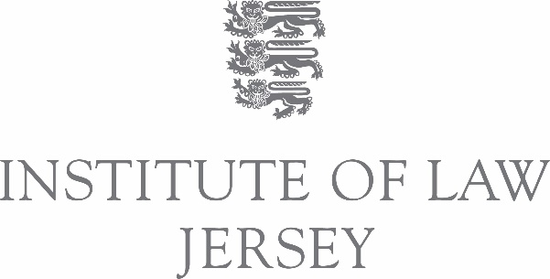

Teaching Fellows

Location: Jersey, Channel Islands

Salary: £30,000 (10 Months Contract)

Hours: Full-time (0.6FTE teaching and teaching-related activities/0.4FTE research and scholarship)
Fixed-term contract
Given the type of role and the flexible nature of the Institute’s teaching, some evening and weekend work may be required during the term of the contract.

Benefits: Flight on arrival and departure

Dates: 5 August 2024 – 31 May 2025
- On-island from 5 August 2024 to 28 March 2025
- Remote working 28 March to 31 May 2025

Closing date: 29 February 2024

We are seeking to appoint enthusiastic and collaborative early to mid-career academics to assist our current Faculty in providing teaching and supervision on our University of London undergraduate LL.B. programme. Applicants must be suitably qualified and have some previous experience of teaching law at undergraduate level.

About the Institute of Law
Founded in 2008, the Institute of Law is an independent, not-for-profit body based in Jersey, providing academic and professional legal education. With an emphasis on promoting knowledge and learning through first-class teaching and research, the Institute offers innovative programmes ranging from the prestigious University of London LL.B. and a partnership with the University of Toulouse, to higher degrees in Jersey law and professional qualifications for advocates and solicitors throughout the Channel Islands. The Institute offers students small classes in a personalised and friendly learning environment.

Your Teaching
Our teaching takes a varied approach (e.g. lectures, tutorials, workshops etc.) and is complemented by a personal tutorial system that offers all our students bespoke pastoral and academic support. Teaching Fellows will be expected to design and deliver a range of interactive and engaging activities for our learners for up to three modules. Each cohort of students receives approximately 180 hours of timetabled classes during each academic year, supplemented with study skills workshops, personal and professional development planning, personal tutorials and extra-curricular activities. You will also be involved in the design and marking of formative assessments.

We are particularly seeking applicants who can contribute to the following modules:

Level 4:  - Contract Law  - Criminal Law  - Legal System and Method  - Public Law  Level 5:  - Tort Law  - Commercial Law  - EU Law  - International Protection of Human Rights  - Property Law | Level 6:  - Jurisprudence and Legal Theory  - Company Law  - Dissertation  - Equity and Trusts  - Intellectual Property Law

Further information about these modules, including a brief syllabus, is available on the University of London’s website at LLB Bachelor of Laws | University of London

How to apply
For further information including a detailed job description and person specification, please visit our website at https://www.lawinstitute.ac.je/visiting-teaching-fellows.

To apply, please send the following to administration@lawinstitute.ac.je by the below deadline.

- a copy of your curriculum vitae
- a letter of application (two sides maximum) outlining how you meet the criteria for the role (
- a completed teaching competency grid

If you would like an informal chat about the role, please get in touch with Rose Parkes, Associate Dean (Academic Programmes), via email at: rose.parkes@iol.ac.je

Application Deadline
The closing date for applications is 5.00 p.m. on Thursday 29 February 2024.

Interview Dates
First interview (online via Teams) Monday 25 March 2024
Second interview (in person) Wednesday 1 May 2024 – venue TBC

